

COMMUNITY RESOURCE MAPPING
A guide to understanding your community’s response to psoriatic disease

Community resource mapping is a method of showing information about occurrence, distribution, access to, and use of resources in a defined area.

What is it useful for?
- This tool allows us to explore how people understand their local environment and resources. Cartographic precision is not important in this tool. It is not designed for demarcating boundaries or calculating areas.
- It can also help examine relationships between different factors (resources, awareness, access) and in identifying problems and opportunities.
- In the context of crisis preparedness, this tool can be used to map and discuss hazard prone areas. For more in-depth analysis of crisis vulnerabilities, explore a separate risk mapping technique.
- Identifying the location, access, and use of key resources, including, for example, health centers, specialists with awareness of psoriatic disease, pharmacies that carry psoriatic disease medications, and patient organization branches.
- Monitoring changes in resources over a period of time.

How to do it
Allow approximately 3 hours for this exercise.
- Find a suitable place to hold your activity, and collect the required materials. This could be on the ground using stones and sticks, on the floor using chalk, or directly on a large sheet of paper using colored pencils and pens.
- Agree with participants exactly what area the map will cover, such as a town, a municipality, a country, etc.
- Explain that the quality of the drawing is not important and it does not matter if the map is entirely accurate or to scale. If any of the participants are illiterate, it is important to use symbols and drawings, with a key to interpret the symbols into local language.
- Start by preparing the outline or boundary of the map and then identify the central point or an important landmark within the area (such as a school, market, or government building).
- Resources and other important landmarks can now be drawn. Participants should develop the content of the map according to what they think is most important. The map doesn’t not need to show every individual hospital building, shop, or house, but rather the area where they are located. Local resources may include:
  - Hospitals
  - Specialist offices (dermatologists, rheumatologists, and more)
  - Health centers
  - Psoriatic disease clinics
  - Health worker availability
  - Patient association branches
  - Pharmacies
  - Transportation availability
  - Barriers to travel (such as mountains, rivers, dangerous areas, etc.)
  - Locations factors that may be unhelpful to your work (for example, corrupt traditional medicine practitioners)
  - Schools
  - Key locations for awareness raising
  - Landmarks that are important to your association and your work
- Although it may take some time to get going, the process should not be rushed. Once the map is underway, sit back and observe, and only interrupt if absolutely necessary in order to clarify something or help participants if they get stuck.
Picture 1: Example community resource map
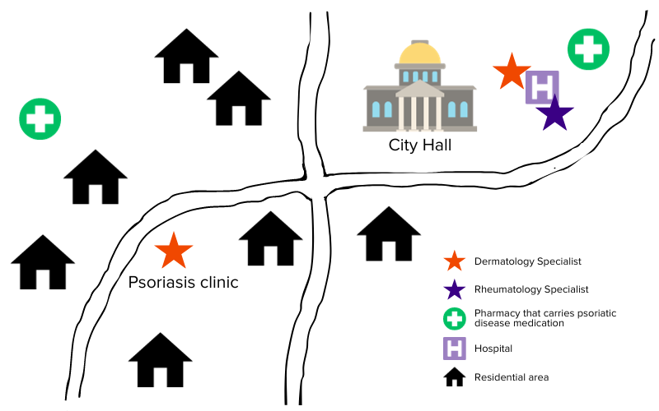
- If the map is being drawn on the ground, make a copy onto paper or take a photograph. It is important to copy a permanent record of the map.
- If participants have sufficient time, it might be useful to draw a series of maps to illustrate changes over time, or to use map drawing as a “visioning” exercise to explore the desired future.
- Discuss and analyze the map(s). What can you learn from it? If there are several different groups creating maps, each group should present and describe its map to the others for their reactions and comments. Are there major differences? If so, note these and whether consensus is reached. Note that a consensus is not necessarily the desired outcome; differences in perceptions can be a very useful basis for further discussions.

Questions to guide discussion and analysis
The following questions can be used to guide the discussion.
- What resources are abundant or scarce?
- Are there any gaps?
- What resources are used? Which are unused?
- Which resources are degrading? Which are improving?
- What other changes have there been over the years?
- Which resources are there most problems with? Why?
- Who makes decisions about resource allocation?
- Does the village have resources held in common? How are decisions made about how common resources are used?
- Where do people go to access doctors and reliable medical advice? Who can access this?
- Where do people go to get medication for psoriatic disease? Who can access this?
- How does access to these resources vary between social groups? Has this access changed? If so why, when, and how?
- Which areas are most vulnerable to risk (for example, in times of crisis)?
- Which opportunities can you identify?
- Does the map explain any dynamics you have understood in your community?

Once the map has been completed, it can be used as a basis for conducting interviews about topics of interest, or making project plans.

